Jason Palmeri

CSD200

Assignment 10.2

**Responsive**

<https://www.dfy.co.kr/>

<https://www.twitch.tv/>

**Non-Responsive**

<http://www.wholesalegaming.biz/>

<https://worcester.craigslist.org/>

Web pages as a whole have been advancing pretty quickly in the last few years. With the switch from just writing standard HTML and CSS to now using javascript frameworks to create component driven web pages, responsive design has become equally important. As some websites embrace this new style of writing web pages, some have just completely ignored it, and have gone for desktop only experiences. While I was looking around for websites with good responsive design I came across dfy.co.kr, a website from Korea that has won many awards for it's design and responsiveness. At first glance, it’s almost like a work of art, as you scroll through the page and see it's many different sections come into your viewport, with the trailing cursor following your every movement. It’s an interesting website that, as you shrink it down to mobile sizes, continues to keep it's design philosophy intact. The second website I chose is twitch.tv, a website for people to stream themselves to others. I use this site frequently to watch people play games and chat. What I love about twitch is it's modularity. There's 3 sections on the site, following, main area, and the chat. What twitch does best is allow you to close both the following section, and chat section so you can closely follow the main area, or you can just close the following section to view both chat and the video. The website automatically does this for you as well when you start shrinking down to mobile sizes. Wholesalegaming.biz is a retailer that sells trading cards at wholesale prices.The problem with their website is that they seem to have forgotten about flex boxes, or have just never thought about upgrading their website. The design of the website is fine, but I’d say to fix the overflow-x problems they could simply add a flex box to their main components. My second website actually shocked me, craigslist. Something so big and well known, does not use standard web design philosophies? This website, like the previous one, could be fixed with just some simple flex boxes, and again the design isn't really the problem with the responsiveness.

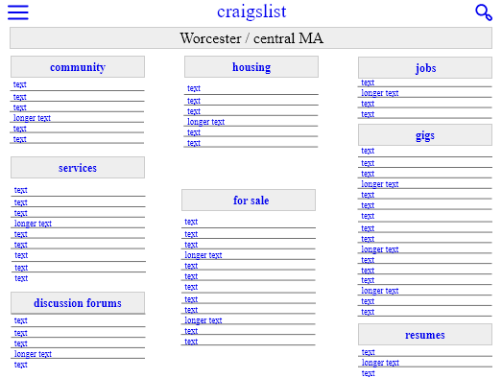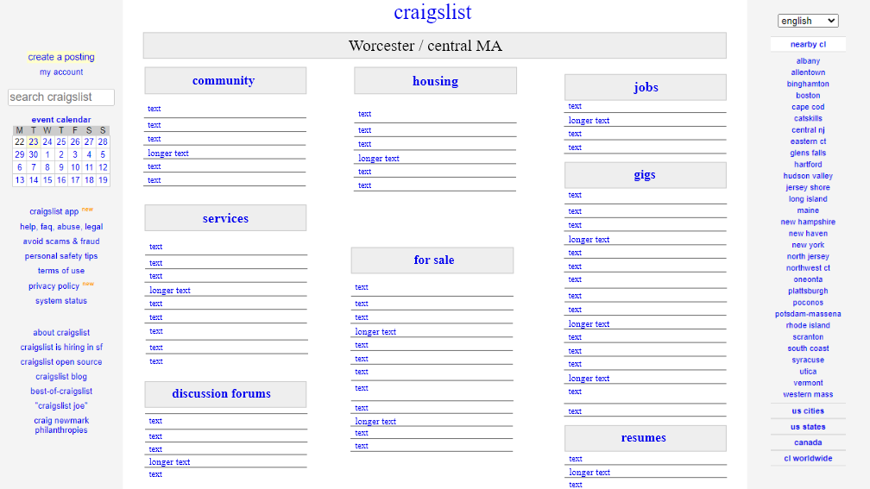

For craigslist I wanted to stay true to the original design. The desktop version of the website is perfectly fine, they are going for a simple design, for a simple service. As the page gets smaller on tablet devices I decided to hide the left and right menus so that you could see more of the main content. On mobile I went for a flex grid of the items, so that you can easily scroll down the list of available services



Again I stayed somewhat true to the original design, though it's kind of funny how hills wholesale website is written, it's actually an entire table, the website is literally just built on a table. I added a slideshow for more content, and again on tablet and mobile devices shrunk the extra menus, to extend the main content.